Course Title: Healthy Snacking

Grade Level: 6th - 8th grade

Description:
In this module, you will learn about healthy snacking. You will explore what it looks like, what to choose, and how to create healthy habits when snacking.

*ADD Standards*

Course Image:
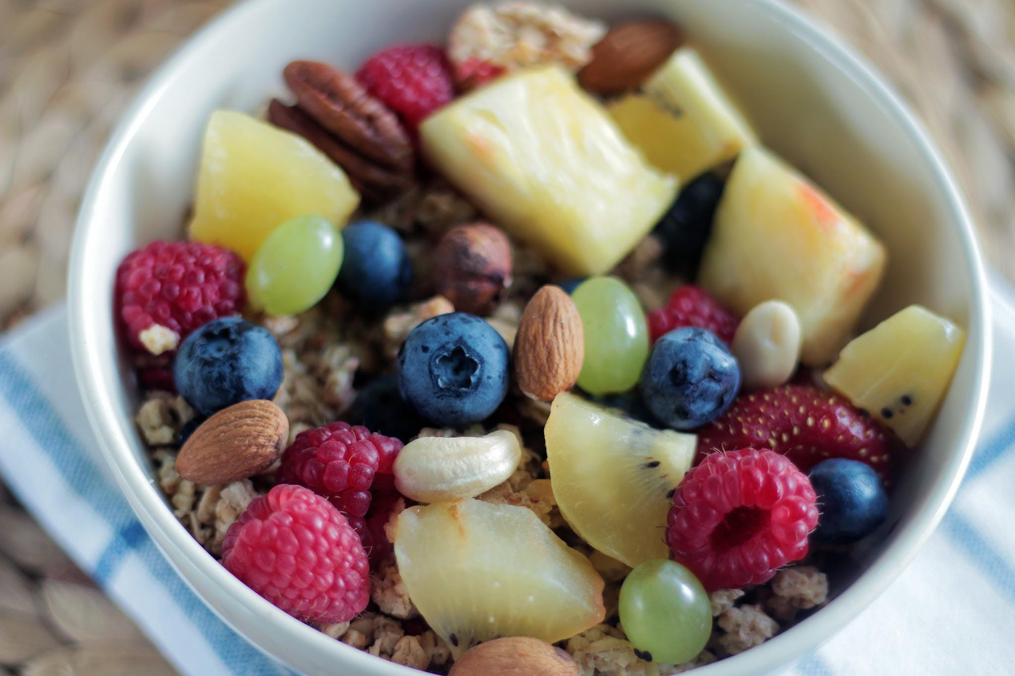
Video URL:
https://www.youtube.com/watch?v=Nfb2cojZ_Dg

